**Customer Name: Pentagon**

DTD – 08-07-2022

1. **Application Need:** CustomizedSoftware interface for data transfer from SAP GUI to Videojet TTO machine.
2. **Customer Product –** Pouch (Plastic – HDPE)

1. **Coding requirement –**

Data is to be read from FTP server, based on label generated by SAP URL with respect to process order ID. Excel sheet to be maintained and shared in a common folder of local PC connected to TTO, by customer .The excel sheet should contain the below data along with Order ID and label.

Refer below excel file format.

|  |  |  |  |  |  |  |  |
| --- | --- | --- | --- | --- | --- | --- | --- |
| Label type | Process order no. | Batch no. | Date of manufacture | Date of expiry | MRP | Hardcoded | Unit sale price |
| LabelABC | 20000046453 | 0001060502 | 16-06-2022 | 16-06-2023 | 25.65 | (inclusive of all taxes) | 50.55 |

1. **Proposed Customized Interface Overview:**

* PC to be provided by customer and connected to Videojet TTO Printer via LAN using LAN cable.
* 2 different IP addresses will be assigned to PC & printer respectively, for communication.
* Interface will have an option for the user to enter the Order ID. After fetching this ID, interface will find the respected URL from the SAP.
* SAP will read the ID and will give a response in form of label.
* Interface will get connected to the FTP server of user. After entering label name in the same server , it will search the text file and the file will get loaded and interface will read that file.
* The file contains the following format of data.

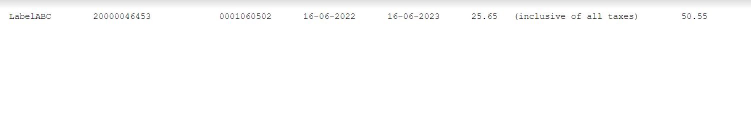

* The user will enter the batch quantity on interface that has to be printed.
* After commanding start button, respected quantity will get print and will get auto stop after reaching the final count.
* A report(Excel File) file to be generated after the completion of batch.
* This report to contain all the details with respect to printed components in a given batch, Order ID, Label(Generated by SAP Server),Batch No, Packaging Date, Expiry Date, MRP, USP.
* In this application rejection is not being tracked or compared with input file.
* Login ID & Password to be given for customized software application.
* PC and UPS, in customer scope.

1. **Operational Instructions –**

* Printer and PC to be powered ON
* Customized interface software to be opened in the PC.
* Order ID to be entered on interface.
* Text file to be displayed in Customized software application
* Quantity to be entered for the batch.
* Start button to be clicked to start the Batch.

1. **Performance Parameters.**

* Marking of 2 Variables, alphanumeric and 2D QR code.
* Transfer of 2 Variables from excel file to Videojet printing machine cycle-wise.

1. **Prerequisite considered for the offered software-**

1. Single phase 230V Input power supply for printer and PC
2. PC is in customer scope.
3. Connectivity between PC and printer to be arranged by customer(LAN Cable).
4. Note: